2018 Criminal Pretrial Technique Conference
Facilitators

 | Biography
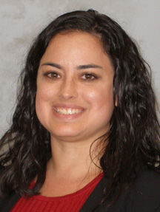 | Amaryllis Austin joined the federal system in 2009 as a U.S. Pretrial Services Officer Assistant in the Northern District of California; a year late, she was promoted to U.S. Pretrial Services Officer. In September 2016, Amaryllis was selected to participate in a one-year temporary duty assignment at the Administrative Office of the U.S. Courts as one of two Director Leadership Program Residents. Her focus during that year was to research the effect of the statutory presumption for detention on low-risk pretrial defendants.  Amaryllis has a B.A. in Government from Cornell University and a M.A. in Criminology from the University of California, Irvine.
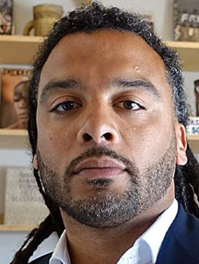 | Adam J. Foss is a former Assistant District Attorney in the Juvenile Division of the Suffolk County District Attorney’s Office (SCDAO) in Boston, MA, and a fierce advocate for criminal justice reform and the importance of the role of the prosecutor in ending mass incarceration.  In February of 2016, Mr. Foss delivered a TED talk that has already eclipsed 2 million views. In 2015, he was voted one of the country’s 40 most up-and coming lawyers by National Law Journal and in 2013, the Massachusetts Bar Association voted him Prosecutor of the Year.
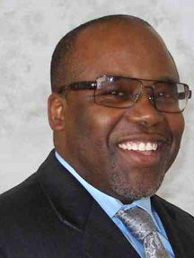 | Bill is a native of Virginia and is a graduate of James Madison University in Harrisonburg, Virginia. He is a veteran of the United States Marine Corps. During his career, Bill has worked as a juvenile correctional officer, half-way house case worker, and pretrial investigator. Bill was hired by the United States Pretrial Services Office, in the Eastern District of Virginia, in 1998. He rose from a Pretrial Services Officer Assistant to supervisor responsible for managing a specialized unit in pretrial services investigation and supervision. Bill has also led in the development and implementation of the Pretrial Risk Assessment (PTRA). In April 2014, Bill joined the AO’s Probation and Pretrial Services Office, where his primary area of responsibility is Pretrial Services.
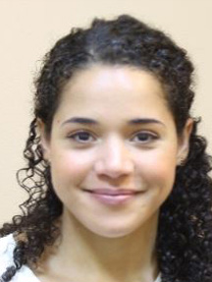 | Cassandra Snyder is an Education Attorney in Probation and Pretrial Services Education at the Federal Judicial Center. Before joining the FJC, Cassandra was Director of the Criminal Defense Clinic at DC Law Students in Court. Cassandra received an LLM in trial advocacy as an E. Barrett Prettyman Teaching Fellow at Georgetown Law Center where she tried felony and misdemeanor cases in D.C. Superior Court and supervised third-year law students in Georgetown's Criminal Defense & Prisoner Advocacy Clinic. She has been a member of D.C. Superior Court's Criminal Justice Act panel and worked as an Assistant Defender with the Philadelphia Defender Association. She has served as an adjunct professor in criminal defense clinics for George Washington Law School, the Catholic University Columbus School of Law, and the University Of District Columbia David A Clarke School Of Law. She received her J.D. from NYU Law School where she was a Root Tilden Kern Public Service Scholar and her B.A. magna cum laude from the University of Pennsylvania.
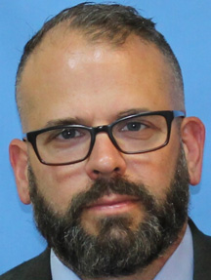 | Christopher T. Lowenkamp received his Ph.D. in Criminal Justice from the University of Cincinnati and is currently a social science analyst for the Administrative Office of the US Courts, Probation and Pretrial Services Office. Prior to his appointment at the AO, Dr. Lowenkamp was a research professor and the director of the Center for Criminal Justice Research at the University of Cincinnati. Dr. Lowenkamp’s research interests include pretrial and post-conviction risk assessment, effective supervision practices, treatment and intervention quality and program evaluation.  Dr. Lowenkamp has been involved in the development of six risk assessments and has published over 25 articles on the topic of risk assessment. He has written numerous practice related curriculum and materials such as Effective Practices In Correctional Settings-II (EPICS-II), Staff Training Aimed at Reduction Re-arrest (STARR), the Post-Conviction Risk Assessment (PCRA), the Pretrial Risk Assessment (PTRA) and the Public Safety Assessment (PSA). Dr. Lowenkamp is internationally recognized as an expert in the field of corrections and has been awarded the Simon Dinitz Award by the Ohio Justice Alliance for Community Corrections, the MacNamara Award by the Academy of Criminal Justice Science, and the Dan Richard Beto Award by the National Association of Probation Executives. Dr. Lowenkamp has been named as one of the top 100 most influential criminologists based on publication records and a top ten scholar based on research grant acquisition.
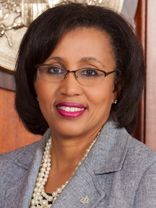 | Judge Roby is the Chief United States Magistrate Judge for the United States District for the Eastern District of Louisiana and has served on the court for eighteen (18) years where she handles criminal and civil matters and also serves as a mediator. Administratively, she serves on the Court’s Technology Committee. She is also a Division Director for the ABA Litigation Sections and a former Co-Chair of the Sections member of Diversity and Inclusion Committee and its Alternative Dispute Resolution Committee.  Judge Roby is published in the areas of social media and ethics, settlement and ethics and attorney’s fees. Judge Roby serves as an Adjunct Professor at Tulane University Law School where she teaches a course on E-Discovery and Digital Evidence. She is a graduate of Tulane University Law School and Xavier University of New Orleans. She is a recipient of the Inaugural 2017 Chief Justice Bernette Joshua Johnson Trailblazer Award for her work in diversity initiatives.
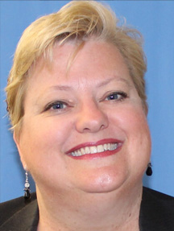 | Kathryn N. Nester earned both her undergraduate and J.D. degrees from the University of Texas. Before her appointment to her current position of Federal Public Defender for the District of Utah in August of 2011, Kathy held the position of Assistant Federal Public Defender for the Southern District of Mississippi for six years. Prior to that, Kathy was a trial lawyer in private practice in the Jackson, Mississippi area for thirteen years and represented plaintiffs in personal injury and civil rights cases and federal and state criminal defendants. She has handled over fifty jury trials including capital murder, complex fraud and wrongful death cases and was awarded Mississippi Trial Lawyer of the Year in 2001. She has appeared numerous times before the Fifth and Tenth Circuit Courts of Appeals for panel and en banc arguments and, in 2014, she appeared before the United States Supreme Court as co-counsel in USA v. Kevin Loughrin.  As Federal Public Defender for the District of Utah, Kathy supervises over 45 employees while continuing to handle complex cases and serving on multiple court committees. Kathy is a frequent speaker at local and national training seminars and has appeared in national and international media in several of her high profile cases. In 2010 she was inducted as a Fellow of the American College of Trial Lawyers. In 2013, Kathy was recognized as one of the Top Lawyers in Utah. In 2015, she was inducted as a fellow of the International Society of Barristers. Kathy currently serves as representative for the Federal Public Defenders on the U.S. Deputy Attorney General’s Reentry Roundtable Committee and she served for two years on the national Clemency Project 2014 Steering Committee. Kathy and her husband Steven have been married for 26 years and they have two daughters, Katie (21) and Caroline (19).
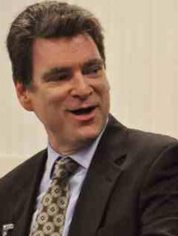 | Matthew G. Rowland has led the Probation and Pretrial Services Office (PPSO) in the Administrative Office of the U.S. Courts (AO) since January 2012. Before that, he served as second-in-charge of that office for nearly a decade. The statutory duties delegated to him by the Director of the AO include providing oversight and support to the federal probation and pretrial services system, which is the largest pretrial and community corrections organization of its kind. Matt has focused on the areas of strategic planning, interagency coordination, policy and procedure development, budget planning, professional skills training and program assessment.  A native of New York City, Matt holds a bachelor of arts degree with honors from St. Francis College in Brooklyn and was an honor student at Brooklyn Law School where he earned his juris doctorate degree. Matt is admitted to the bar in the State of New York.
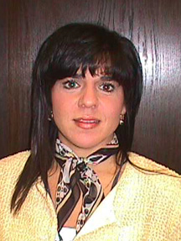 | Susie Merchant, Sr. Education Specialist at the Federal Judicial Center, is passionate about teaching and learning and Probation and Pretrial Services. Susie has worked in probation and pretrial services in both state and federal systems for 27 years. As a former probation officer, she believes that providing opportunities for continued learning and education in the system is critical to officers’ individual growth, and to the success of the overall mission. Since joining the FJC in 2007, Susie has managed many programs for staff at all levels, and has conducted presentations on topics ranging from leadership and organizational transition to treatment services and evidence based practices. Susie obtained her Bachelor's degree in criminal justice from Sam Houston State University in Huntsville, Texas, and a Master's degree in public justice from St. Mary's University in San Antonio, Texas, where she also taught as an adjunct professor.
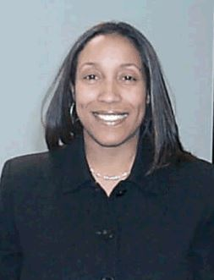 | In February 1993, Robin Grimes began her career as a United States Probation Officer in the Western District of Michigan. She served the Court and community in the capacity of a pretrial service officer, presentence writer and supervision officer. After two years she transferred to the Eastern District of Michigan. She served in various leadership roles in Michigan to include a Mental Health Specialist, Supervisor, AO Program Review Team, Search Team Coordinator and National Firearms Instructor at the Federal Law Enforcement Training Center. Shortly following the completion of the FJC Leadership Development Program in 2013, she was appointed Assistant Deputy Chief in the Northern District of Ohio. In her role as an Assistant Deputy Chief, she utilized a results driven approach in managing projects and leading initiatives. In addition, her position granted her the opportunity and forum to facilitate training and performance reviews to coach, mentor and cultivate staff.
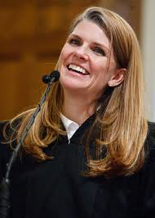 | Evelyn J. Furse is a Federal Magistrate Judge for the United States District Court for the District of Utah. She was appointed to this position on May 1, 2012 and her current term will expire on April 30, 2020. Judge Furse serves on the local rules committee for the District of Utah and Utah Supreme Court’s Advisory Committee on the Rules of Civil Procedure.  Judge Furse earned her bachelor's degree from the University of North Carolina, cum laude, in 1993, and her Juris Doctor from New York University School of Law, cum laude, in 1996. After graduating from law school, Judge Furse served as a law clerk for Chief Justice Christine M. Durham of the Utah Supreme Court. She then worked as an associate in the Washington, D.C. office of Covington & Burling before returning to Utah, where she took a job with Howrey LLP, eventually becoming a partner in the firm and focusing on complex corporate litigation. In 2006, Judge Furse transitioned her practice to the Salt Lake City Corporation, where she handled civil litigation as a Senior City Attorney. Judge Furse worked in this position until she was appointed to the court.
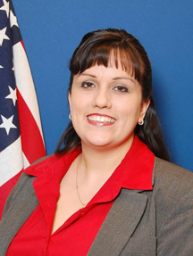 | Sara Valdez Hoffer is a Senior US Probation Officer for the District of Kansas. She has worked for the District of Kansas for over ten years, specializing in pretrial services and treatment services and she currently serves as the district's coordinator for evidence-based practices in pretrial. Sara has been serving a temporary duty with the Administrative Office, working with Bill Hicks on pretrial matters, for three years. As part of her TDY, she leads the PTRA certification training, assists with the DROP program and other district technical assist programs, and developed a guide for best practices in evidence-based practices for pretrial. In addition to her work with the AO, Sara has worked as a facilitator for the Federal Judicial Center since 2013, leading the MEET on Common Ground program and she is a graduate of the Federal Judicial Center's Leadership Development Program.  Sara has a B.A. in Criminal Justice and a M.A. in Public Administration both from Park University, Kansas City, Missouri.

